**SNOW Case Reminder**

Gabriel Boçon, Victor Gasparoni

Increases quality of life inside Snow’s environment by adding a page dedicated to incidents sent to other groups.

1. Installing Tampermonkey

This script works with a chrome extension called Tampermonkey, which can be installed from the link below:

<http://tampermonkey.net/>

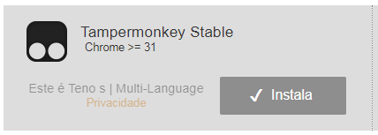

*Install Tampermonkey Stable.*

After installing it, we can follow the steps bellow to configure the necessary filter for us to open the case reminder page.

1. On Service Now

On the Service Now page, we have to create a filter and save it as a favorite. For this, open any incident list page and set a filter like so:

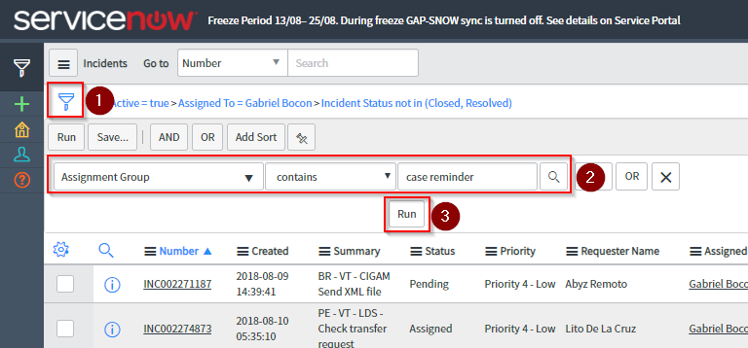

The filter must be set as Assignment Group > contains > case reminder. Click Run and you will be greeted by the following screen:

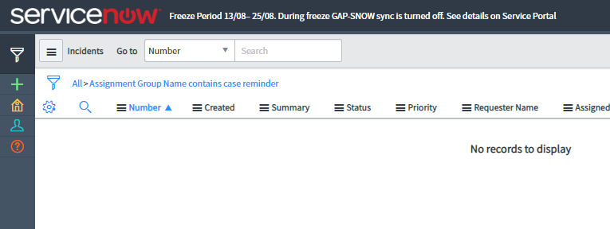

This is correct, because we now want to save this filter as a favorite. For this, follow the steps:

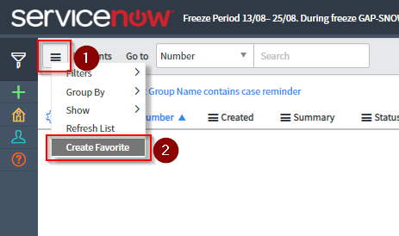

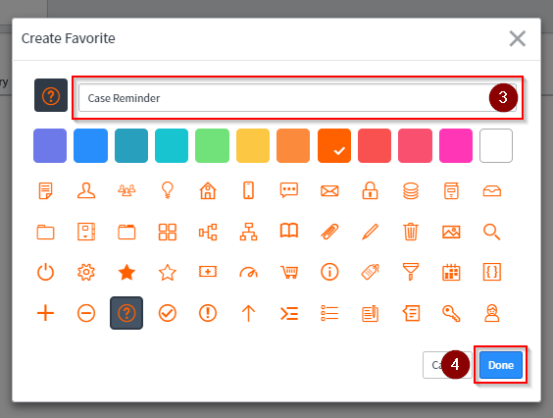

1. On Tampermonkey

Download the file below to a folder of your liking:



After downloading the .zip file, launch Tampermonkey in Chrome according to instructions below.

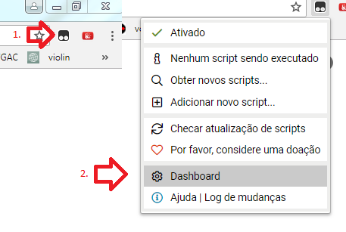

*Click on Tampermonkey’s icon, then Dashboard.*

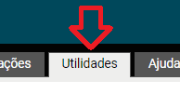

*Go to the utilities tab.*

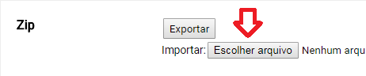

*Click on the Choose File dialog, on the Zip section.*

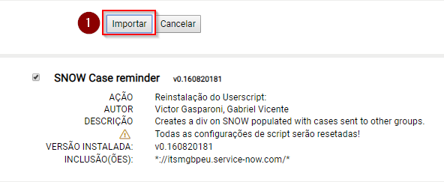

*Then click on Import.*

1. Ready to test

Now you can return to Service Now and test it. Click on the favorite you just created. You should be greeted by the following screen:

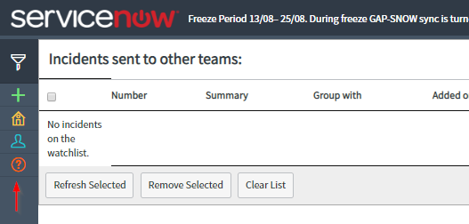

*Cases added to the watchlist will be shown here.*

Now, whenever you open an incident, there will be a button called “Add to watchlist”. This button adds a case manually to the watchlist.



*Button to add a case to the watchlist.*

However, when you change the assignment group to any other than the one specified in the code (lines 476, 484), the script detects this change and also prompts you asking whether you would like to add it to the watchlist or not.

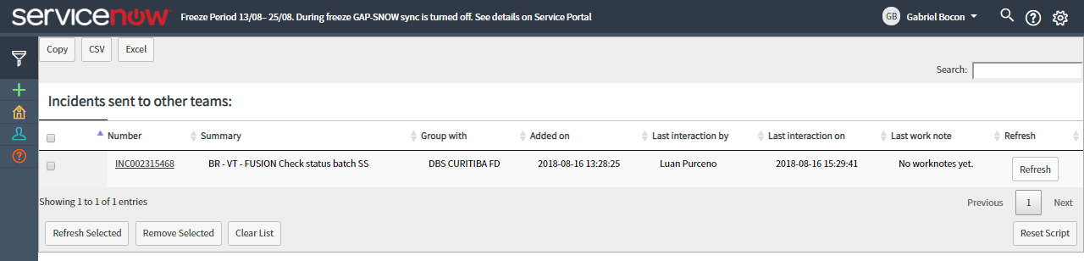

*An incident added to the watchlist.*

On the Case Reminder page we can do some actions, like removing incidents from it, updating their information, accessing it’s page through the incident number.

|  |  |
| --- | --- |
| **Created by:** | Gabriel Boçon, Victor Gasparoni |
| **Revision:** | 02A 08/28/2018 |